DSA0601 – DATA HANDLING AND VISUALIZATION USING R
SET 6: PRODUCT SALES ANALYSIS
Dataset: Monthly Product Sales
Product ID | Product Name | January Sales | February Sales | March Sales
1 | Product A | 2000 | 2200 | 2400
2 | Product B | 1500 | 1800 | 1600
3 | Product C | 1200 | 1400 | 1100

PROGRAM 1: GROUPED BAR CHART
Aim
To create a grouped bar chart to visualize the sales of each product for the first quarter.
Required Package
No additional package is required. barplot() is available in base R.
R Program
# Monthly Product Sales
sales <- matrix(c(2000, 2200, 2400,
1500, 1800, 1600,
1200, 1400, 1100),
nrow = 3, byrow = TRUE)

rownames(sales) <- c("Product A", "Product B", "Product C")
colnames(sales) <- c("January", "February", "March")

# Grouped Bar Chart
barplot(sales,
beside = TRUE,
main = "Monthly Product Sales",
xlab = "Month",
ylab = "Sales",
col = c("skyblue", "orange", "lightgreen"),
legend.text = rownames(sales),
ylim = c(0, 3000))
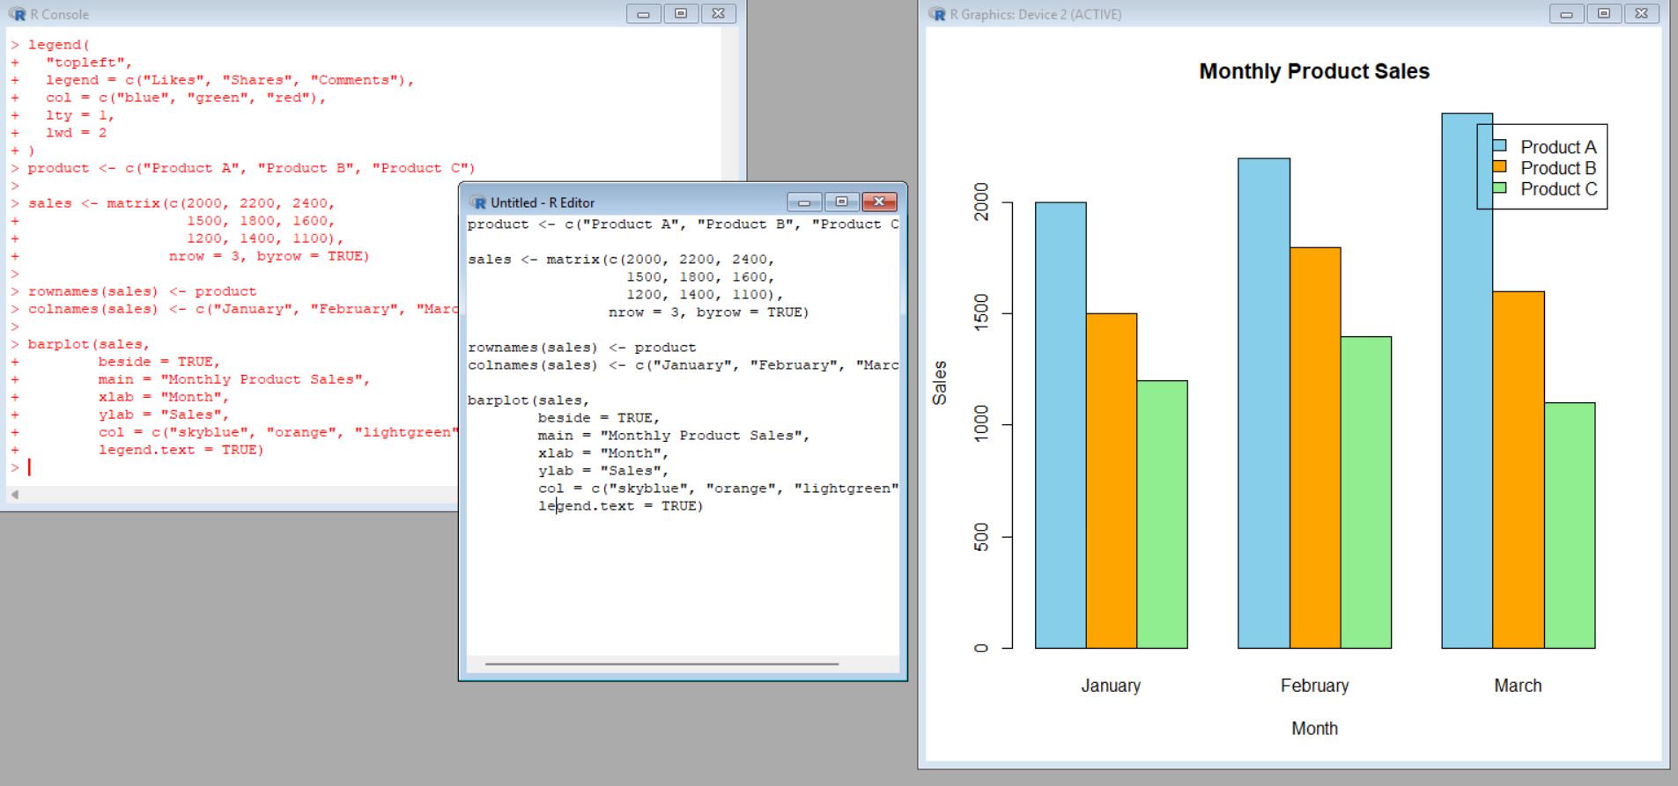
Explanation
- matrix() stores the monthly sales data.
- rownames() gives the product names.
- colnames() gives the month names.
- barplot() creates the bar chart.
- beside = TRUE displays the bars side by side.
- main gives the chart title.
- xlab and ylab label the axes.
- legend.text displays the product names.
- col gives different colors to the products.
Expected Output
A grouped bar chart showing January, February, and March sales for Products A, B, and C.
Observation
Product A has the highest sales in all three months. Its sales increase from 2000 in January to 2400 in March. Product C has the lowest sales in March with 1100.

PROGRAM 2: STACKED AREA CHART
Aim
To create a stacked area chart representing the overall sales trend for all products over the three months.
Required Package
No additional package is required. Base R functions are used.
R Program
# Monthly Product Sales
months <- 1:3

product_a <- c(2000, 2200, 2400)
product_b <- c(1500, 1800, 1600)
product_c <- c(1200, 1400, 1100)

# Cumulative values
total_a <- product_a
total_b <- product_a + product_b
total_c <- product_a + product_b + product_c

# Empty plot
plot(months, total_c,
type = "n",
main = "Overall Product Sales Trend",
xlab = "Month",
ylab = "Sales",
xaxt = "n",
ylim = c(0, 6000))

axis(1, at = 1:3, labels = c("January", "February", "March"))

# Stacked areas
polygon(c(months, rev(months)),
c(total_a, rev(rep(0, 3))),
col = "skyblue")

polygon(c(months, rev(months)),
c(total_b, rev(total_a)),
col = "orange")

polygon(c(months, rev(months)),
c(total_c, rev(total_b)),
col = "lightgreen")

legend("topleft",
legend = c("Product A", "Product B", "Product C"),
fill = c("skyblue", "orange", "lightgreen"))
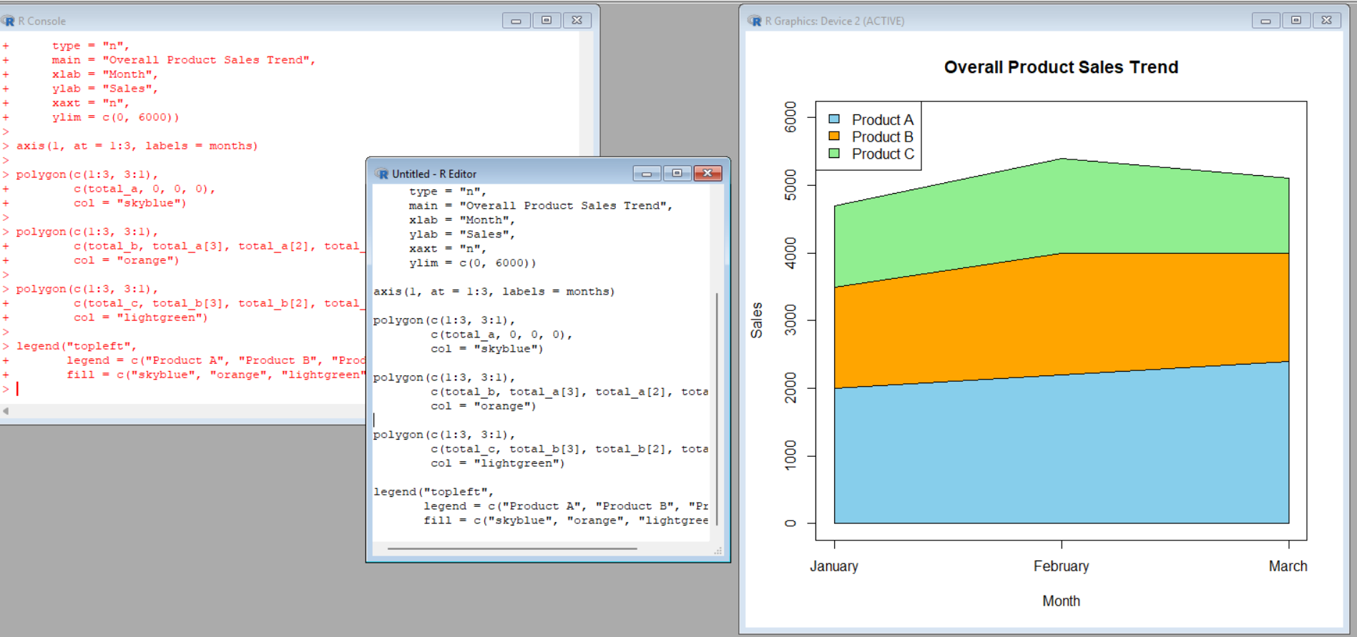
Explanation
- months represents January, February, and March.
- product_a, product_b, and product_c store the sales values.
- total_a, total_b, and total_c calculate cumulative sales.
- plot(type = "n") creates an empty plotting area.
- polygon() creates the different areas.
- The areas are placed one above another to form a stacked area chart.
- legend() displays the product names.
Expected Output
A stacked area chart showing the overall sales contribution of Products A, B, and C over January, February, and March.
Observation
The total sales are:
Month | Total Sales
January | 4700
February | 5400
March | 5100
Overall sales increase from January to February and then decrease slightly in March.
PROGRAM 3: TABLE OF MONTHLY SALES
Aim
To create a table showing the monthly sales data for each product and label the table elements.
Required Package
No additional package is required. data.frame() and print() are available in base R.
R Program
# Monthly Product Sales
sales_data <- data.frame(
Product = c("Product A", "Product B", "Product C"),
January = c(2000, 1500, 1200),
February = c(2200, 1800, 1400),
March = c(2400, 1600, 1100)
)
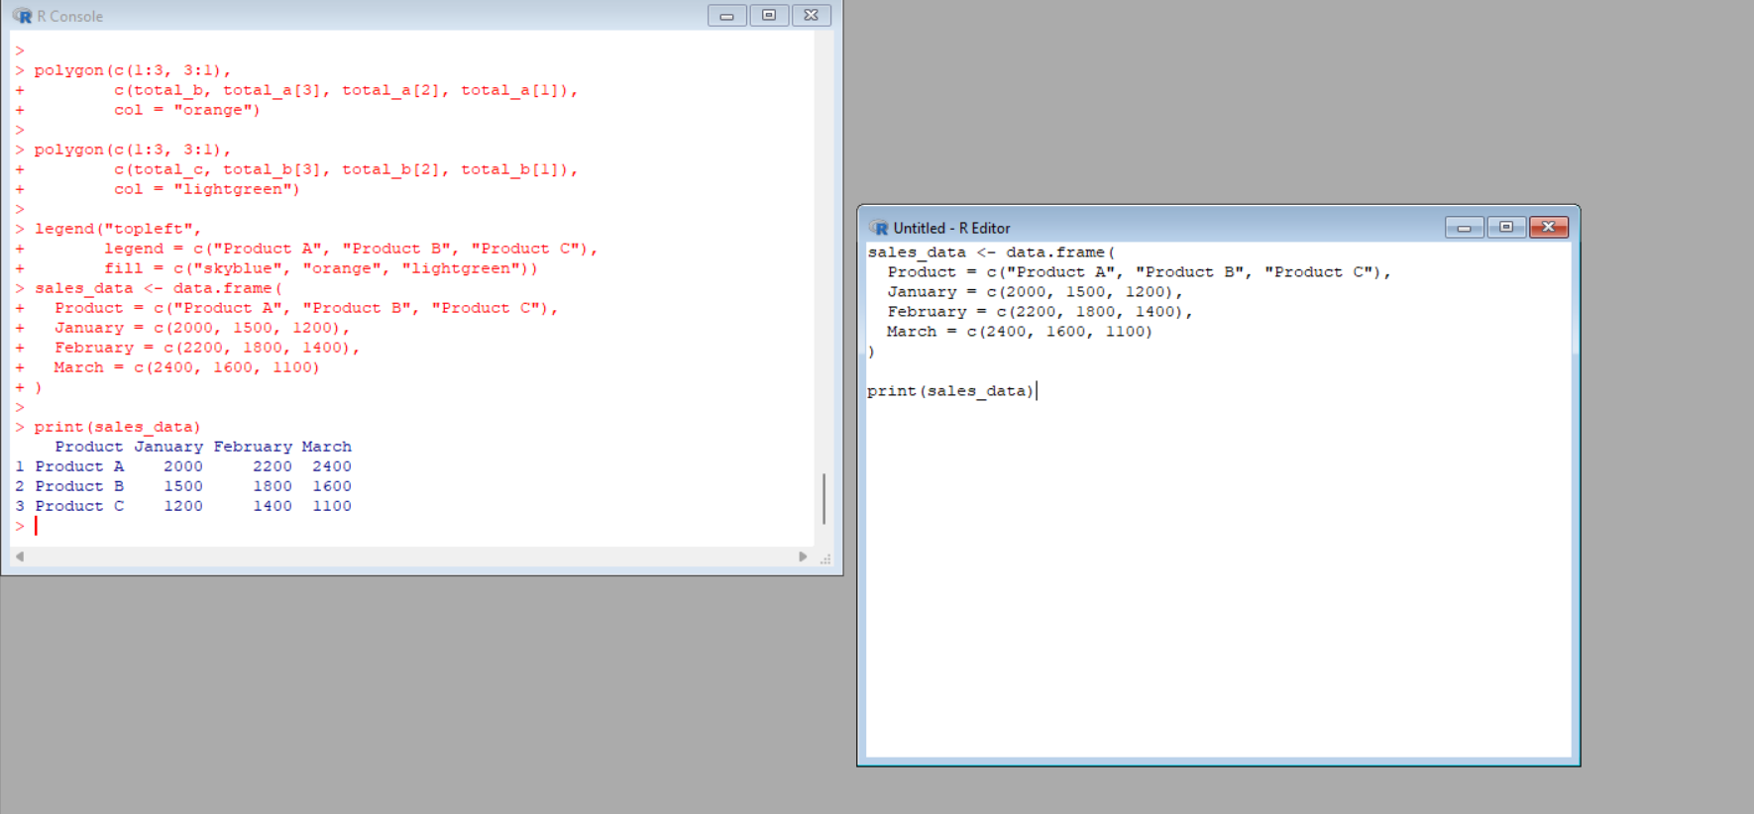

# Display Table
print(sales_data)
Explanation
- data.frame() creates a table.
- Product contains the product names.
- January, February, and March contain monthly sales.
- print() displays the table in the R console.
Expected Output
Product January February March
1 Product A 2000 2200 2400
2 Product B 1500 1800 1600
3 Product C 1200 1400 1100
Observation
The table clearly displays the monthly sales of all three products and makes it easy to compare their sales values.

PROGRAM 4: TABLEAU DASHBOARD
Aim
To develop a Tableau dashboard combining the grouped bar chart, stacked area chart, and sales table for interactive exploration of product sales data.
Step 1: Create the Excel File
Create an Excel file named:
Product_Sales.xlsx
Enter the following data:
Product ID | Product Name | January Sales | February Sales | March Sales
1 | Product A | 2000 | 2200 | 2400
2 | Product B | 1500 | 1800 | 1600
3 | Product C | 1200 | 1400 | 1100
Save the file.

Step 2: Open Tableau
- Open Tableau Desktop or Tableau Public.
- Click Connect to Data.
- Select Microsoft Excel.
- Select Product_Sales.xlsx.
- Select the sales sheet.
- Click Sheet 1.

Step 3: Prepare Data for Tableau
For the area chart, the monthly columns need to be converted into a single Month field.
- Go to the Data Source page.
- Select:
  - January Sales
  - February Sales
  - March Sales
- Right-click and select Pivot.
- Rename:
  - Pivot Field Names → Month
  - Pivot Field Values → Sales
The data will now have:
Product Name | Month | Sales
Product A | January Sales | 2000
Product A | February Sales | 2200
Product A | March Sales | 2400
Product B | January Sales | 1500
... | ... | ...

WORKSHEET 1: GROUPED BAR CHART
Steps
- Create a new worksheet.
- Drag Month → Columns.
- Drag Sales → Rows.
- Drag Product Name → Color in the Marks card.
- Select Bar from the Marks card.
- Make sure the bars are displayed side by side.
- Drag Sales → Label to display sales values.
- Rename the worksheet:
Grouped Product Sales
Expected Output
A grouped bar chart comparing the sales of Products A, B, and C for January, February, and March.

WORKSHEET 2: STACKED AREA CHART
Steps
- Create a new worksheet.
- Drag Month → Columns.
- Drag Sales → Rows.
- Change the Marks type to Area.
- Drag Product Name → Color.
- Make sure the areas are stacked.
- Rename the worksheet:
Stacked Sales Trend
Expected Output
A stacked area chart showing the overall sales trend and contribution of each product over the three months.

WORKSHEET 3: SALES TABLE
Steps
- Create a new worksheet.
- Drag Product Name → Rows.
- Drag Month → Columns.
- Drag Sales → Text in the Marks card.
- Select Text Table if required.
- Rename the worksheet:
Monthly Sales Table
Expected Output
A table displaying the sales of each product for January, February, and March.

STEP 4: CREATE TABLEAU DASHBOARD
- Click New Dashboard.
- Give it the name:
Product Sales Analysis Dashboard
- Drag Grouped Product Sales into the dashboard.
- Drag Stacked Sales Trend into the dashboard.
- Drag Monthly Sales Table into the dashboard.
- Arrange the three visualizations neatly.

STEP 5: ADD INTERACTIVITY
Product Filter
- Select the Product Name field.
- Add it as a filter.
- Allow users to select:
  - Product A
  - Product B
  - Product C
  - All Products
Month Filter
You can also add the Month field as a filter to allow users to view specific months.
Use Chart as Filter
Select the grouped bar chart and choose Use as Filter.
Now, when a user selects a product in the bar chart, the other visualizations can respond to the selection.

PROCEDURE
- Create the monthly product sales dataset.
- Store the sales values in an R matrix.
- Use barplot() to create a grouped bar chart.
- Calculate cumulative sales values for the stacked area chart.
- Use polygon() to create the stacked areas.
- Create a data frame containing the monthly sales.
- Display the sales table using print().
- Create an Excel file containing the product sales data.
- Open Tableau and connect to Microsoft Excel.
- Pivot the monthly sales columns for Tableau visualization.
- Create the grouped bar chart.
- Create the stacked area chart.
- Create the monthly sales table.
- Combine all three visualizations into a Tableau dashboard.
- Add filters and interactive chart selection.

RESULT
The monthly product sales data was successfully analyzed and visualized using a grouped bar chart, stacked area chart, and sales table in R. An interactive Tableau dashboard was also created by combining the three visualizations, allowing users to explore product sales across January, February, and March.

